CLEAN AND TRANSFORM DATA ASSIGNMENT

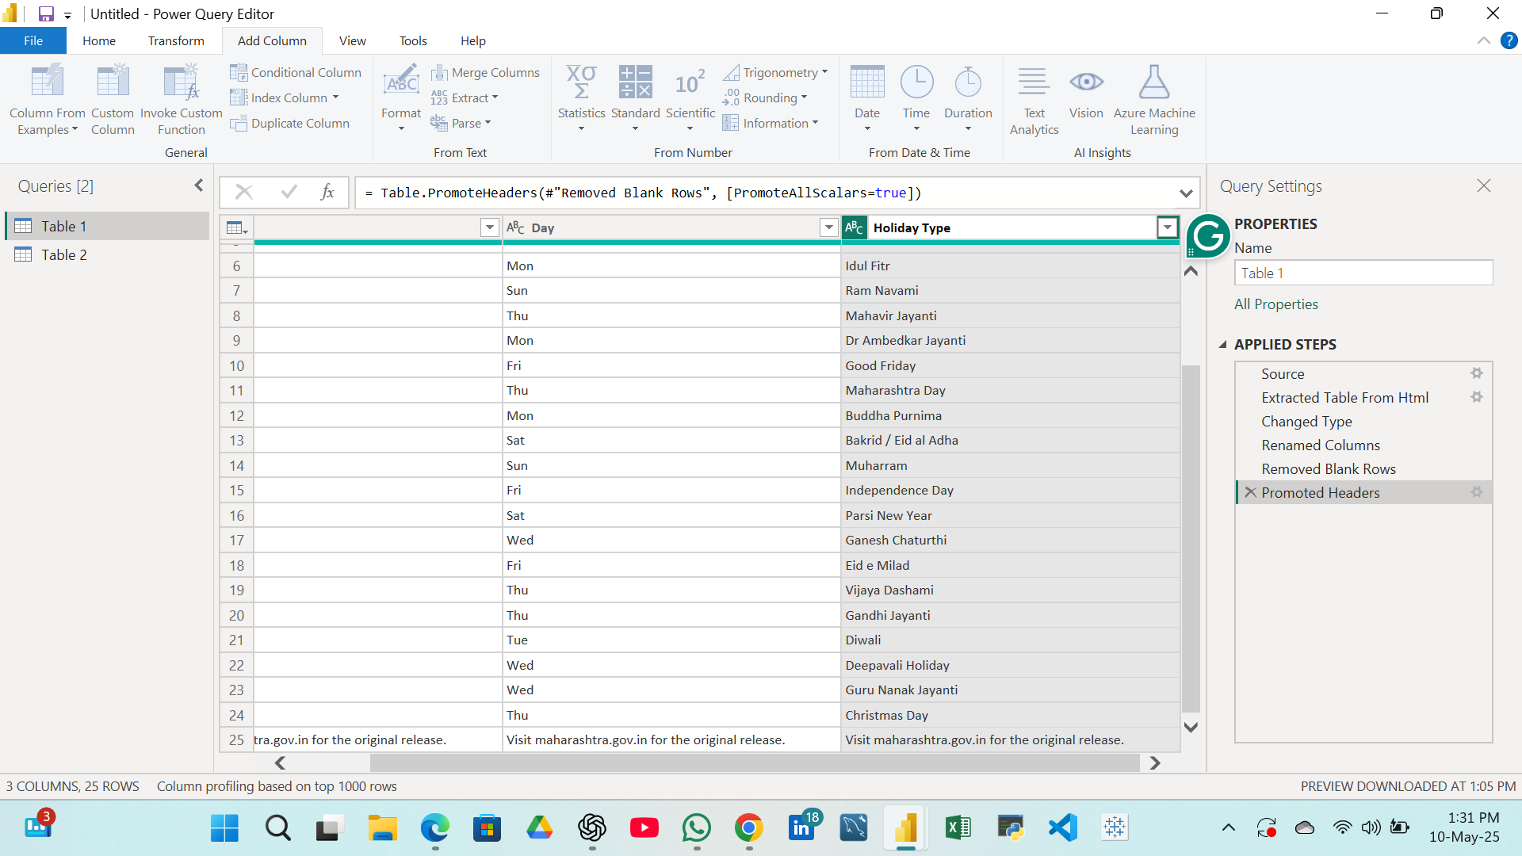
1) Rename columns to: Date, Holiday Name, Holiday Type.

2) Change the Date column to Date format.
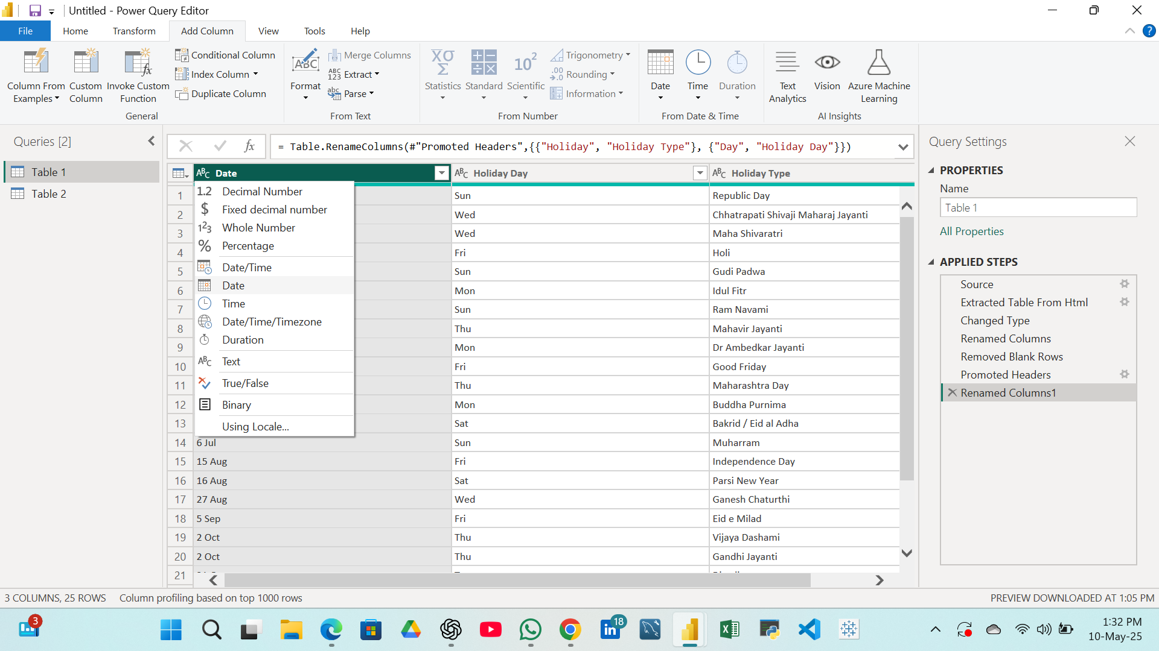

3) Add a new column Month from the Date.
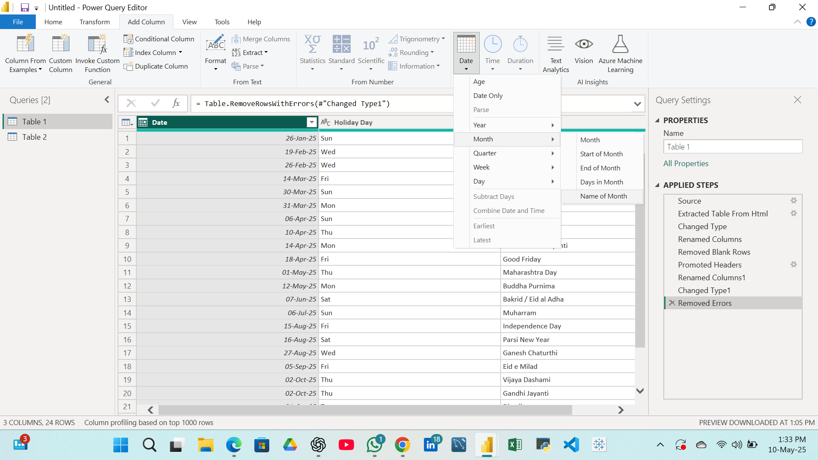

4) Add a custom column Day of Week.

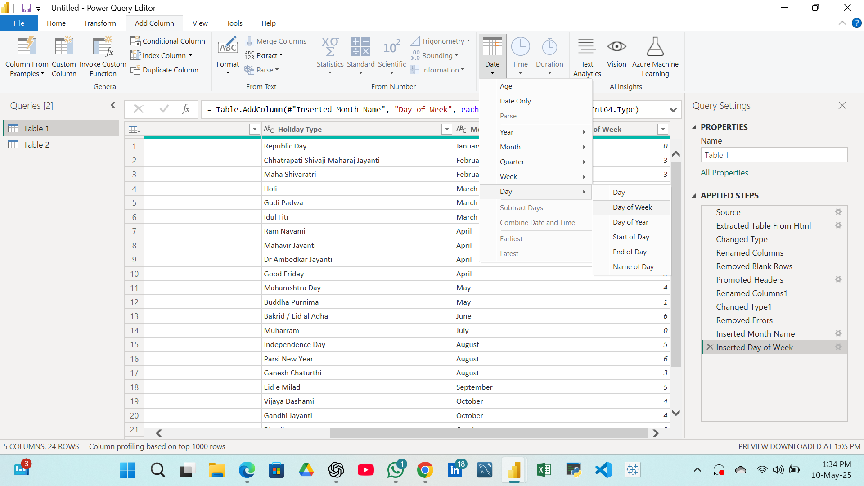
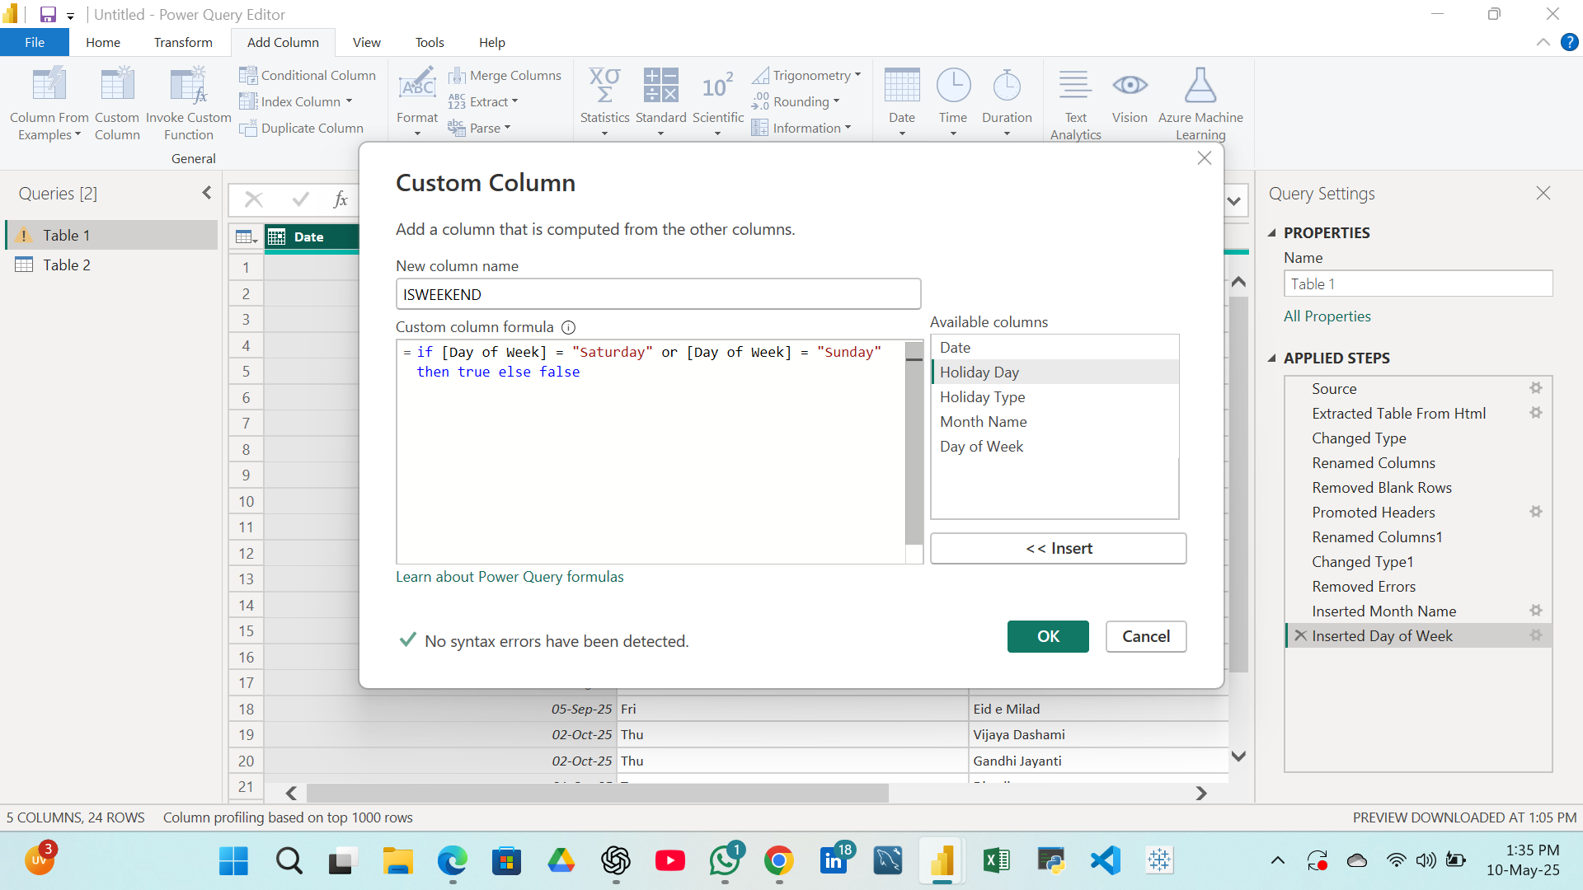
5) Add a column IsWeekend – Flag if the holiday falls on Saturday or Sunday.

6) Add a calculated column IsLongWeekend – Flag as "Yes" if the holiday is on Friday or Monday.

